Minutes of the General Meeting of the Comstock Grizzlies
Saturday April 15th @ 6 pm
Ken and Nathan’s Home – Sparks

General information and attendance:

Meeting called to order @ 7:27 pm by President Ken

Meeting Attendee’s: Nathan, Ken, Dan, Tom,
Dean, Thomas, Steve, Max, Bob, John, Ben, Jim

Attendee’s: 12

March 2023 minutes were sent to group.

Motion to approve as updated and reviewed.
Motion: Max Second Dan, Approved by acclimation.

Current information for these minutes.
Treasurers Report: Through 04/15/23

Previous Balance: $ 411.16
Transactions: IN $ 00.00

Transactions: OUT $ -00.00
Ending Balance: $ 411.16
Net Change: $ 00.00

Motion to approve Treasury.
Motion: Max, Second Dan, Approved by acclimation.

Reminder: Dues for Officers need to be paid by Feb. Meeting

Although dues are not required to attend activities.
We are all encouraged to renew your dues
and look at friends to become members.
Just so we have funds for our club expenses.

Web/Facebook Report:
Fully updated

Old Business:

Beer Bust will be Saturday June 17th @ 3pm-6pm.
$10 for members. $15 for guest. Free to new members for
$25 w/ free tee shirt. The club to provide hot dogs and chips.

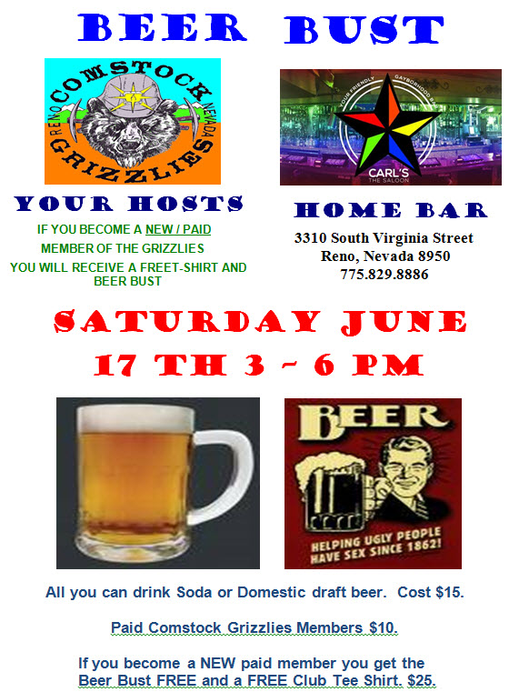

It was shared by Jason that Ron (Bear) of Carl’s Saloon
has passed away. There will be a Celebration of Life on April 23rd Sunday from 2-6 PM @ Carl’s Saloon. I’ll be posting notice on Web Site and Facebook.

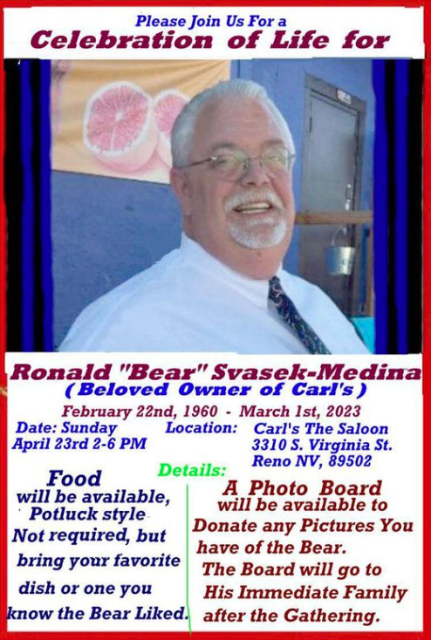

Bowling is done for this year. We will look into
doing again next fall.

New Business:

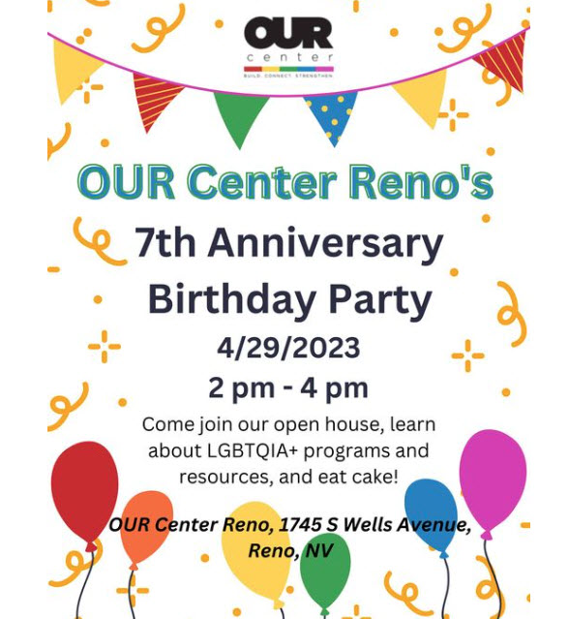

All members are welcome to attend.

Spring and Summer Activity Plans:

Thursday June 8th – 6pm-8pm $15
Nevada Museum of Art
Ghost army: The Combat Con Artist
Of World War II

Friday July 21st – 6pm - $15
Fleischmann Planetarium – UNR
Seasonal Stargazing

Other Activities Discusses but not scheduled:

Aces Baseball Game

Animal Arc Visit

Escape Room

Mini Golf

Movie Night

We will address these and other suggestions in May.

Dinner Night Out – Typically on a Tue, Wed or Thu
On 1st week of month.

Next Dinner Night Out planned:
This month we had 3 excellent suggestion so we
decided to plan ahead for the next 3 Dinner Night Out.

May

Little Waldorf Saloon
1661 N Virginia St, Reno, NV 89503
Thursday May 4^{h} 2023 @ 6:30pm
Menu: https://www.lilwal.com/#menu
Nathan to make a reservation.

June

Carl’s Saloon – 3310 S. Virginia St. Reno
Saturday June 17th from 3-6 PM
Part of our Beer Bust
Meeting @6PM

Pot Luck Dinner and Club Meeting – Typically the 3rd
Saturday of the month

Next Meeting:

May

Dan and Tom’s Home
Carson City, NV
Saturday May 20th 2023 @ 2 PM

Theme: Dan and Tom will be grilling
Burgers and Hot Dogs. We provide
the rest.

June

Carl’s Saloon – 3310 S. Virginia St. Reno
Saturday June 17th from 3-6 PM
Part of our Beer Bust
Meeting @ 6PM

Hope to see you all there.

Close the meeting:
Motion: Max, Second Dan, Approved by acclimation.
Approved at 7:36 PM.

Respectfully Submitted
Nathan C. Secretary
April 20, 2023

